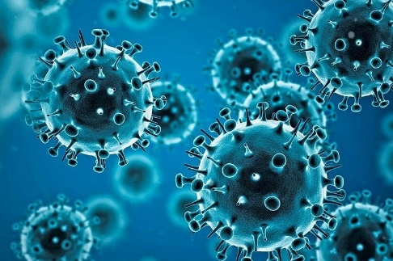**Information: Covid-19 Data analysis.**

**Covid-19**

**Overview:**

Coronavirus disease (COVID-19) is an infectious disease caused by the SARS-CoV-2 virus.

Most people infected with the virus will experience mild to moderate respiratory illness and recover without requiring special treatment. However, some will become seriously ill and require medical attention. Older people and those with underlying medical conditions like cardiovascular disease, diabetes, chronic respiratory disease, or cancer are more likely to develop serious illness. Anyone can get sick with COVID-19 and become seriously ill or die at any age.

The best way to prevent and slow down transmission is to be well informed about the disease and how the virus spreads. Protect yourself and others from infection by staying at least 1 metre apart from others, wearing a properly fitted mask, and washing your hands or using an alcohol-based rub frequently. Get vaccinated when it’s your turn and follow local guidance.

The virus can spread from an infected person’s mouth or nose in small liquid particles when they cough, sneeze, speak, sing or breathe. These particles range from larger respiratory droplets to smaller aerosols. It is important to practice respiratory etiquette, for example by coughing into a flexed elbow, and to stay home and self-isolate until you recover if you feel u nwell.

**Nomenclature:**

During the initial outbreak in [Wuhan](https://en.wikipedia.org/wiki/Wuhan), the virus and disease were commonly referred to as "coronavirus" and "Wuhan coronavirus", with the disease sometimes called "Wuhan pneumonia".In the past, many diseases have been named after geographical locations, such as the [Spanish flu](https://en.wikipedia.org/wiki/Spanish_flu), [Middle East respiratory syndrome](https://en.wikipedia.org/wiki/Middle_East_respiratory_syndrome), and [Zika virus](https://en.wikipedia.org/wiki/Zika_virus). In January 2020, the [World Health Organization](https://en.wikipedia.org/wiki/World_Health_Organization) (WHO) recommended 2019-nCoVand 2019-nCoV acute respiratory disease as interim names for the virus and disease per 2015 guidance and international guidelines against using geographical locations or groups of people in disease and virus names to prevent [social stigma](https://en.wikipedia.org/wiki/Social_stigma). The official names COVID‑19 and SARS-CoV-2 were issued by the WHO on 11 February 2020. The [Director-General](https://en.wikipedia.org/wiki/DGWHO), [Tedros Adhanom](https://en.wikipedia.org/wiki/Tedros_Adhanom) explained that CO stands for *corona*, VI for *virus*, D for *disease*, and 19 for 2019, the year in which the outbreak was first identified. The WHO additionally uses "the COVID‑19 virus" and "the virus responsible for COVID‑19" in public communications.

**Prevention:**

To prevent infection and to slow transmission of COVID-19, do the following:

* Get vaccinated when a vaccine is available to you.
* Stay at least 1 metre apart from others, even if they don’t appear to be sick.
* Wear a properly fitted mask when physical distancing is not possible or when in poorly ventilated settings.
* Choose open, well-ventilated spaces over closed ones. Open a window if indoors.
* Wash your hands regularly with soap and water or clean them with alcohol-based hand rub.
* Cover your mouth and nose when coughing or sneezing.
* If you feel unwell, stay home and self-isolate until you recover.

**Symptoms:**

COVID-19 affects different people in different ways. Most infected people will develop mild to moderate illness and recover without hospitalization.

**Most common symptoms:**

* fever
* cough
* tiredness
* loss of taste or smell.

**Less common symptoms:**

* sore throat
* headache
* aches and pains
* diarrhoea
* a rash on skin, or discolouration of fingers or toes
* red or irritated eyes.

**Serious symptoms:**

* Difficulty breathing or shortness of breath
* Loss of speech or mobility, or confusion
* Chest pain.

Seek immediate medical attention if you have serious symptoms.  Always call before visiting your doctor or health facility.

People with mild symptoms who are otherwise healthy should manage their symptoms at home.

On average it takes 5–6 days from when someone is infected with the virus for symptoms to show, however it can take up to 14 days.

**Covid-19 Cases Graph (India)**

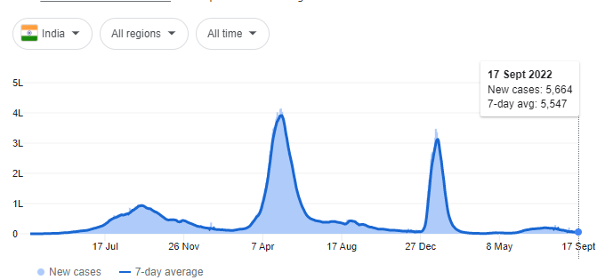

* The above graph shows the trend in the covid-19 in the country India.
* And at present the new cases registered as of 17/09/22 were 5,664 across the country and the 7- day average for the same is 5,547.
* The spike in the graph shows sudden rise in the cases in that period.

**Covid-19 cases Graph (World Wide)**

* The above graph shows the worldwide covid-19 cases.
* There was a sudden rise in the cases in Jan 22, because of the Omicron variant.
* At present the total new cases which was registered over the world is 2,92,167 cases and the 7-day average is 4,92,779 across the world.

**Analysis:**

Q1). What are the total number of confirmed cases in different nations??

Q2). What are the total number of recovered cases in different nations??

Q3). What are the average number of confirmed cases in each state in India?

Q4). What are the average number of recovered cases in states in India?

Q5). Can we show both Confirmed and Recovered cases in India?

Q6) Can we forecast Trend Line for Covid-19?

Q7). Can we group Indian states and find Covid-19 hits?

Q8). Find the highest number of deaths in the world?

Q9). Can we forecast the sheet for future reference??

**Q1). What are the total number of confirmed cases in different nations??**

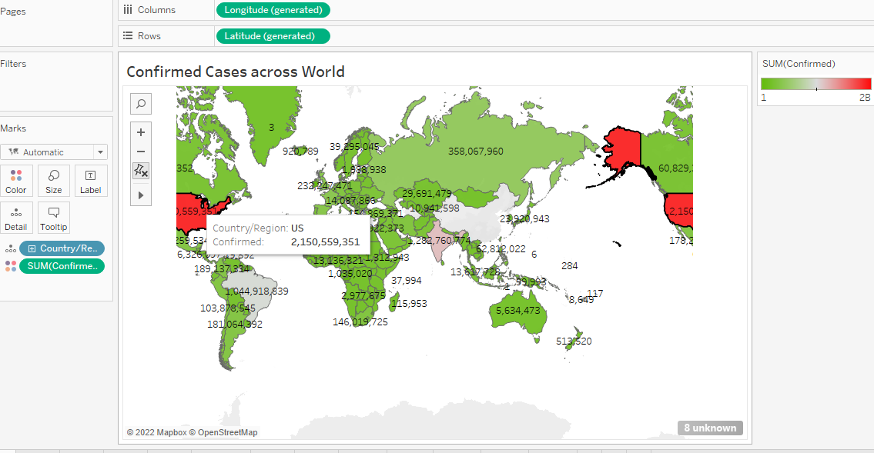

* The above world map indicates the total number of confirmed cases in the international level in the combination of red and green colour.
* Red colour shows the highly effected areas or the region in which the confirmed cases are high.
* So, US is in red colour as the cases in the USA were very high which was 2,150,559,351.
* The lightly effected areas were highlighted in green colour and the moderately effected in white colour.

**Q2). What are the total number of recovered cases in different nations??**

* To represent the total number of recovered cases in different nations I have used two different types of visualization, they are world map and column chart.

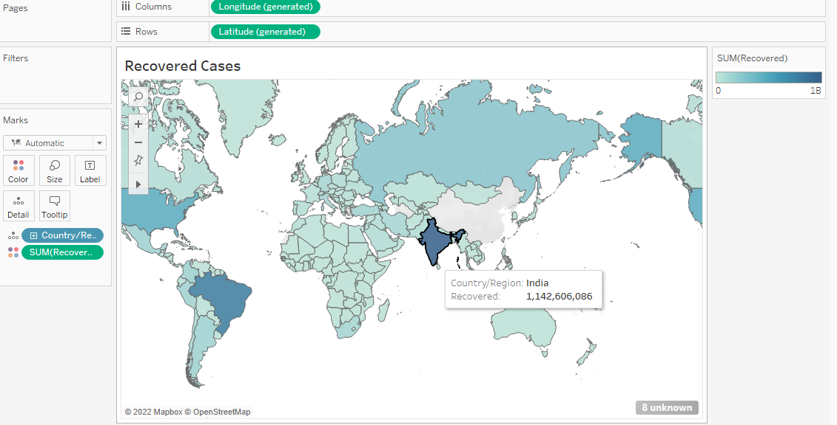

* In the above world map the country with the highest recovered cases is shown in dark blue colour.
* So, India has the highest recovered cases when compared to all over the world, which is 1,142,606,086.
* The country with the least recovered cases is indicated in the grey colour.
* The countries with moderate recovery of cases are indicated in light blue colour.

* The recovered cases are shown in the chart above.
* And here also we can observe that the country with the highest recovery of cases is indicated in the bold line and the country name is India with 1,142,606,086 cases.

**Q3). What are the average number of confirmed cases in each state in India?**

* The above chart shows the average confirmed cases in India of all the states.
* The state with the highest average confirmed cases in India is Maharashtra with the average of 1,161,828
* The state with the lowest average confirmed cases in India is Dadar Nagar Havali with the average of 22.
* And the average confirmed cases for all the states in the country India is 147,290.

**Q4). What are the average number of recovered cases in states in India?**

* In the above chart, India state wise recovery is being shown.
* The average recovery of India state wise is of the state Maharashtra, which is 998,184.
* And the least average recovery as per Indian state wise is of Ladakh.
* The average recovery rate for the whole country, India is including all the states is 130,979.

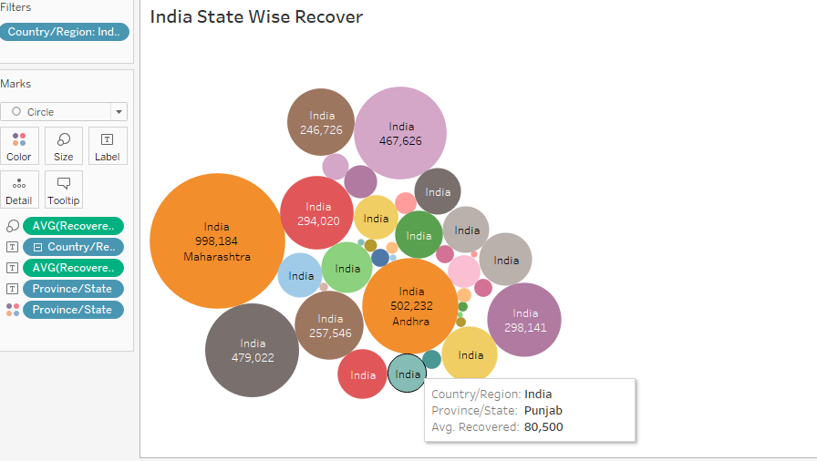

* In the above bubble chart, the size of the bubble indicates the recovery of the state.
* The largest size of the bubble indicates that the recovery rate of that state is higher than all the other states of the country.
* And the smallest size of the bubble indicate that the recovery of the cases is low.

**Q5). Can we show both Confirmed and Recovered cases in India?**

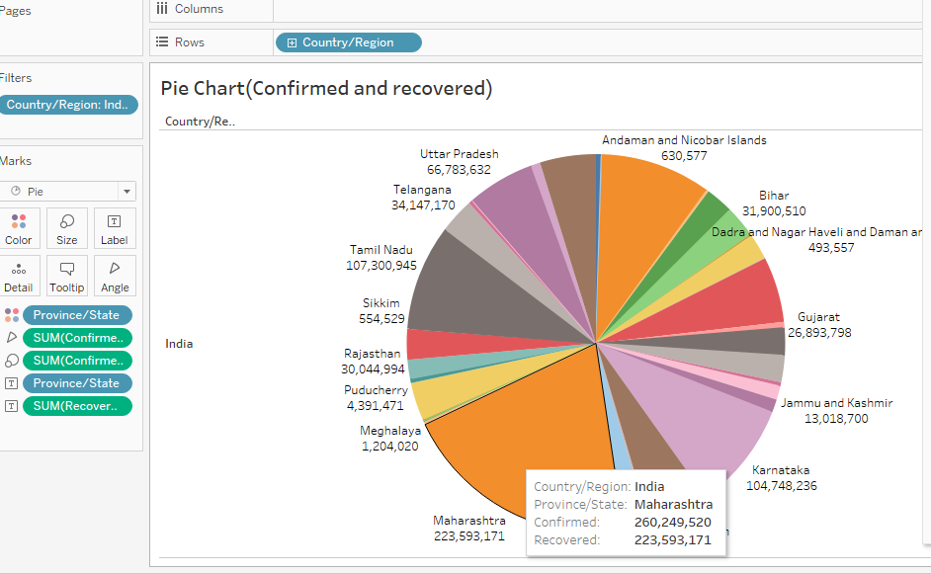

* **Pie Chart:** A pie chart represents data as slices of a circle with different sizes and colours. The slices are labelled and the numbers corresponding to each slice is also represented in the chart. You can select the pie chart option from the Marks card to create a pie chart.
* In the above chart both the confirmed cases and Recovered cases in the country India are shown in the pie chart.
* The state “Maharashtra” occupies the largest space in the pie, and it indicates that across the country the state has the highest number of Recovered cases.
* The UT “Dadar Nagar and Haveli” occupies the smallest part in the pie chart, and it indicates that across the country the state has the lowest number of Recovered cases.
* And both the recovered and the confirmed cases can be seen in the tooltip of the pie chart.

**Q6) Can we forecast Trend Line for Covid-19?**

* **Trend Line:** Trend lines are used to predict the continuation of a certain trend of a variable. It also helps to identify the correlation between two variables by observing the trend in both simultaneously. There are many mathematical models for establishing trend lines. Tableau provides four options. They are Linear, Logarithmic, Exponential, and Polynomial.
* To draw the trend line first we must change the data type of the last update from the string to the date and time. Then we can get the trend line in year, quarter, months, and date.
* Tableau creates the formula with P value and R-square to generate the trend line.
* The first chart shows the trend line for the country India with the year 2020 and 2021.
* So in the chart in the year Jan 2020, the cases are zero, so that point is considered as outlier and after that the cases has start increasing. Then it showed a sudden spike in the Q3 from June which continued to increase till Q4.
* A point can be seen in the Q1 of 2021 with the number of cases to be approx. 200M which indicates that the point is the outlier and the cases decreased at the starting of the year 2021.

* The above chart shows the Trend Line of the world Covid-19 cases.
* Tableau creates the formula with P value and R-square to generate the trend line.
* The second chart shows the trend line for the world for the year 2020 and 2021.
* So, in the chart in the year Jan 2020, the cases across the world are zero, so that point is considered as outlier and after that the cases has started increasing. Then it showed gradual increase from the Q2 from June which continued to increase till Q4.

**Q7). Can we group Indian states and find Covid-19 hits?**

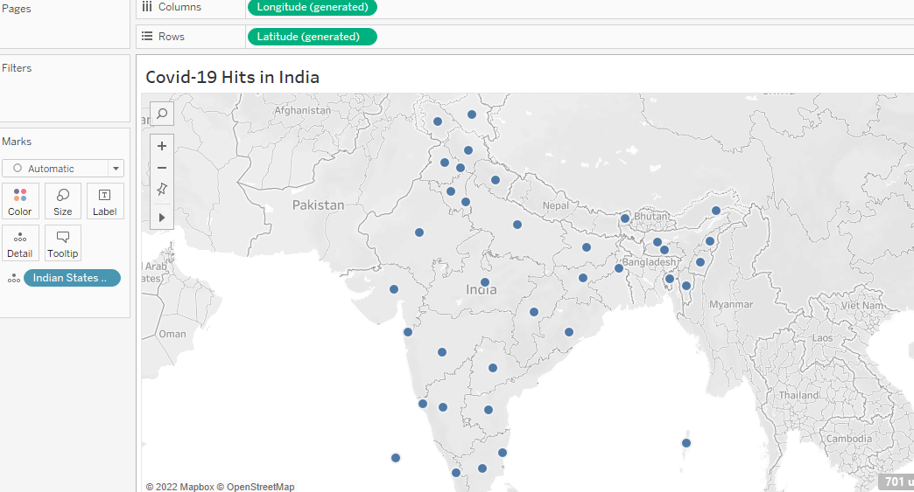

* In the above chart the states of the country India are grouped together to find the covid-19 hits in the country.
* After the grouping has been done the chart is being prepared and the covid-19 stepped in all the states of the country India, which can be seen in the above map of the country.

**Q8). Find the highest number of deaths in the world?**

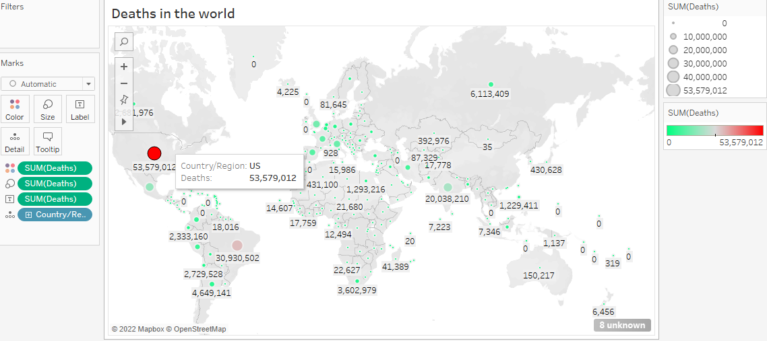

* In the above map, the deaths of the countries are shown in the circle.
* The red colour indicates the highest deaths in the country and the green colour indicates the lowest deaths.
* According to the map US has incurred highest deaths which are 53,579,012, when compared with the other countries.

**Q9). Can we forecast the sheet for future reference??**

* Yes, we can forecast the sheet for the future reference.
* In the year 2020 the number of cases were 7,637,053,464.
* But the number of cases in the year 2021, which were reported were 1,713,033,076. Which indicates that the covid-19 cases has decreased in the year 2021.
* And further for the year 2022, the cases were decreased to 1,094,539,809 according to the forecasting done.

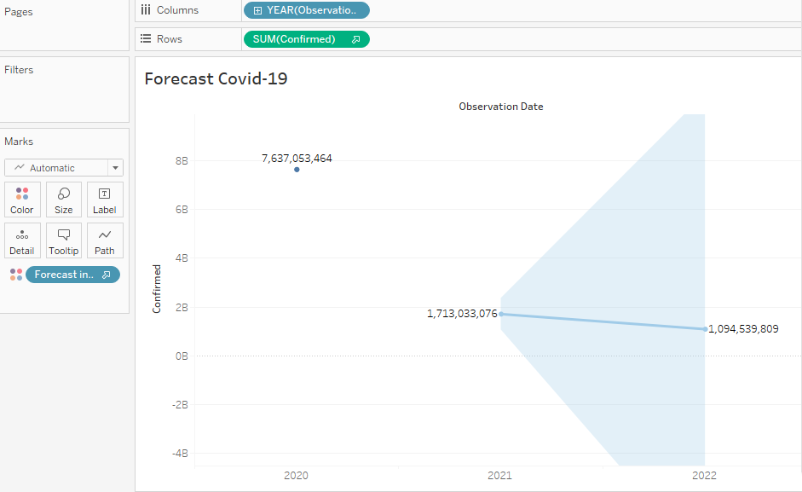

**##Dashboard1**

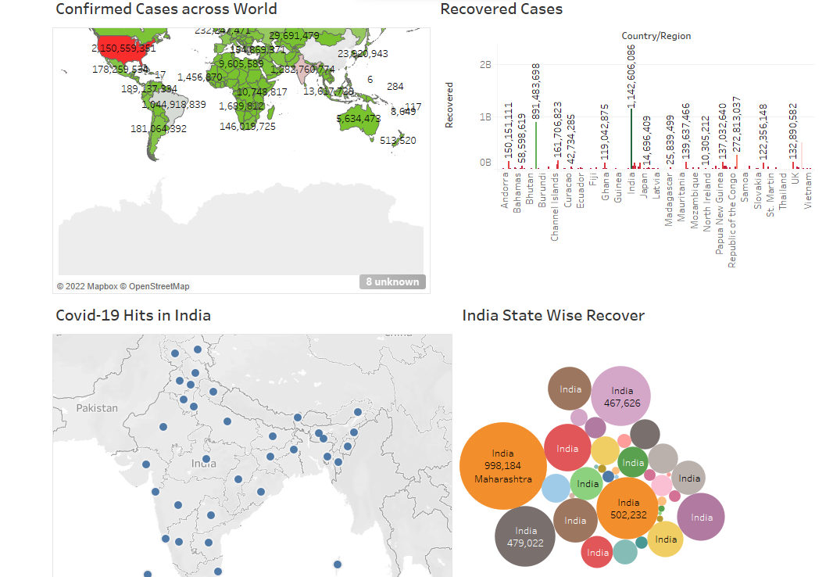

**##Dashboard2**

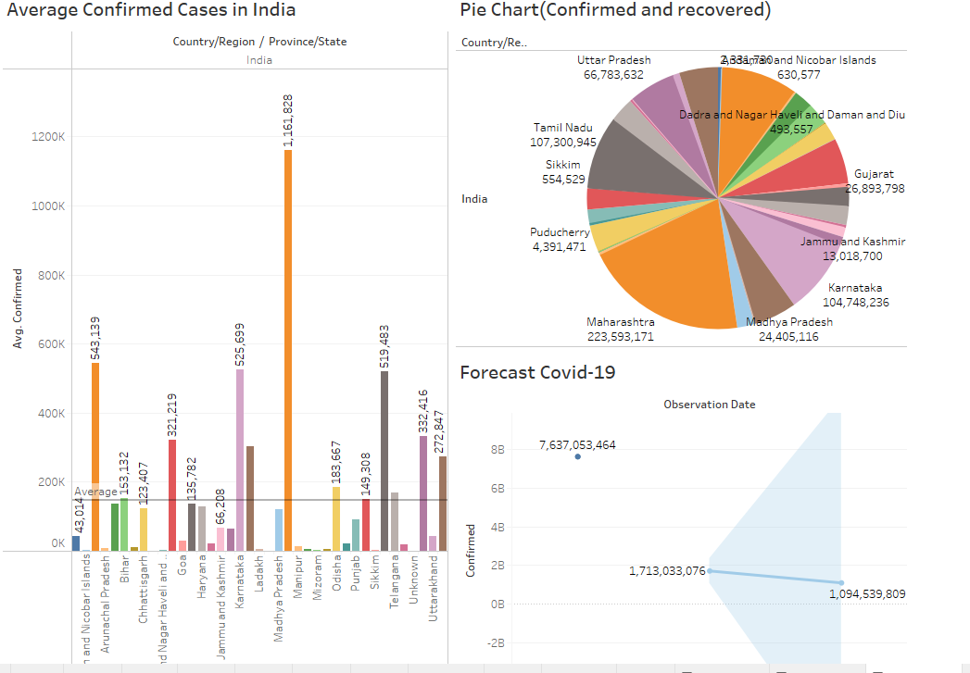

**##Dashboard3**

